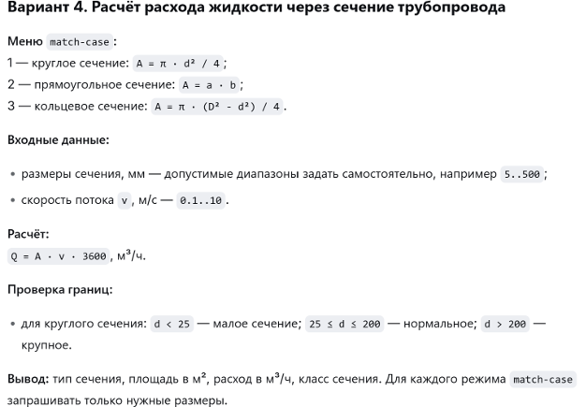

https://github.com/bibhehe898-byte/Laboratory2

дата 7.11.26

